If you have a PC/Laptop with a 9 pin serial socket then all you need is a Null Modem Cable, see pic below.
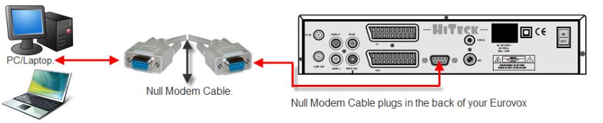
If you have a PC/Laptop that doesn't have the 9 pin serial socket you will need a Null Modem Cable and a USB adapter, See pic below.
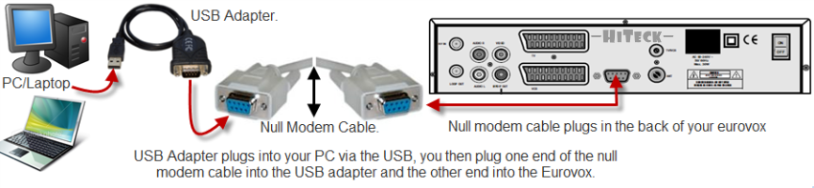
If you have a PC and you are struggling with the usb adapter or you have Vista like me you could install a PCI serial card which is easily added to you PC and with this all you need is the null modem cable which gives you a direct link from your box to the pc.
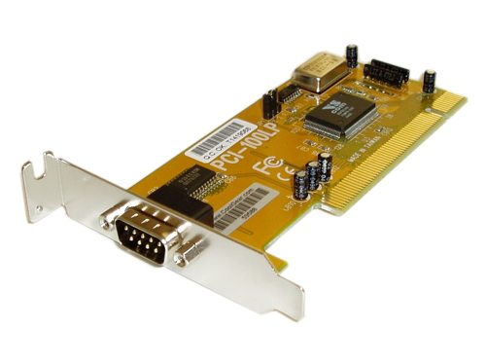
Null Modem Com/Port setup Tutorial
USB DB9 device coms/ports set up.
- Connect your Eurovox unit to your PC using the Null modem serial cable as shown above in the other post.
2. Plug in the power cord on the Eurovox unit and wait until (----) appears on the front display. If it has been flashed before you will see 4 digits instead, leave your Eurovox on standby.
3. On your PC/Laptop Run the UFL Eurovox program which you downloaded in the post above.
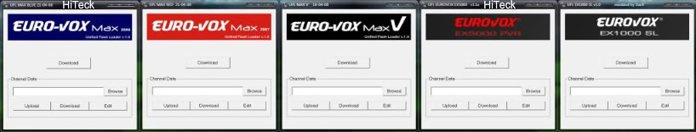
3a (Optional recommended step to save you time) Press the Upload button to save your channel set up favorites etc as they currently are, Save this to a folder on your PC for use later.
4.Click on the 'download' button then wait until you see the following and click start.
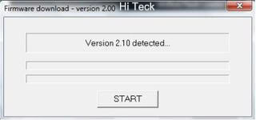
If you do not see this – check your connections between pc & Eurov0x, also if you get the message system reset, turn your box off at the mains, hit the download button then plug your box in, (this may require a few attemps).
5. Now download will start and you will see the following,
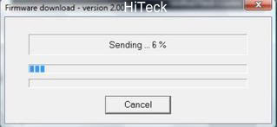
Eurov0x unit will now show dnld flashing on the front display.
6. After the above window – the following will display
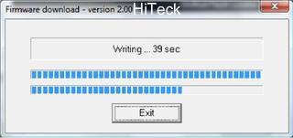
7, When all is finished the following will display,
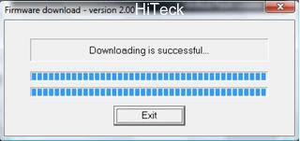
Now your box is done,
If you did the optional step at 3a, then using the UFL click browse to where you saved your file (CDF file) and click download in the lower box on the Kuro program, and it will reload your favorites etc as you originally had them . FREE TO DOWNLOAD THE
- FEEL FREE DOWNLOAD THE SILVERHAZE76 TOOLBAR ON THE LINK BELOW WHARE U CAN FIND ALL EUROVOX BOX UPDATES AND CODES
http://silverhaze76.ourtoolbar.com/exe

